# Introduction to HTML and CSS – CSS Lab

## Topics Covered

* **CSS Syntax**
* **Selectors covered**
  + **Type/Element selector**
  + **Class selector**
  + **Attribute selector**
* **Properties covered**
  + **color**
  + **background**
  + **border**

## Resources

* **CSS element reference on MDN**
  + <https://developer.mozilla.org/en-US/docs/Web/CSS>
* **CSS Basics**
  + <https://developer.mozilla.org/en-US/docs/Learn/Getting_started_with_the_web/CSS_basics>
* **What is CSS?**
  + <https://developer.mozilla.org/en-US/docs/Learn/CSS/First_steps/What_is_CSS>

## Tasks

### Simple Selectors

CSS selectors are used to define a pattern of the elements that you want to select for applying a set of CSS rules on the selected elements.

Картина, която съдържа текст, екранна снимка, Шрифт, дизайн

Описанието е генерирано автоматично

#### Requirements

Create a simple HTML document and apply CSS styling using simple selectors to demonstrate your understanding of CSS type, class, and ID selectors.

* **HTML Document Setup**:
  + Create an HTML document named **index.html**.
  + Include at least one instance of the following elements: **<h1>**, **<h2>**, **<p>**, **<ul>**, **<li>**, and **<div>**.
* **CSS File Setup**:
  + Create a CSS file named **styles.css**.
  + Link the **styles.css** file to your **index.html** document using the **<link>** tag in the **<head>** section.
* **Type Selectors**:
  + Use type selectors to apply styling to all **<h1>** elements to change their font color.
  + Use type selectors to apply styling to all **<p>** elements to change their font size.
* **Class Selectors**:
  + Define a class named **.highlight** that changes the background color of any element it's applied to.
  + Apply the **.highlight** class to at least two different types of elements in your HTML document.
* **ID Selectors**:
  + Define an ID named **#main-title** and apply it to your main **<h1>** element. Style this element to have a unique text color different from other **<h1>** elements.
  + Define an ID named **#special-paragraph** and apply it to one **<p>** element. Style this element to have a distinct font style (e.g., italic).
* **Styling**:
  + Ensure that the **<ul>** element and its **<li>** children have distinct styles. For example, change the list-style-type of **<ul>** and the color of **<li>** items.
  + Apply a different background color to the **<div>** element to distinguish it from the rest of the page.

#### Resources

* [https://developer.mozilla.org/en-US/docs/Web/CSS/CSS\_selectors/Selectors\_and\_combinators#basic\_selectors](https://developer.mozilla.org/en-US/docs/Web/CSS/CSS_selectors/Selectors_and_combinators" \l "basic_selectors)

### Combinators

Combinators define the relationship between the selectors. Using various selectors and combinators, you can precisely select and style the desired elements based on their type, attributes, state, or relationship to other elements.

Картина, която съдържа текст, екранна снимка, линия, Шрифт

Описанието е генерирано автоматично

#### Requirements

Create an HTML document and apply CSS styling using various combinators to demonstrate your understanding of how combinators work to style elements in relation to each other.

* **HTML Document Setup**:
  + Create an HTML document named **combinators.html**.
  + The document should include a nested structure of elements, including **<div>**, **<ul>**, **<li>**, **<p>**, and **<span>** elements, to allow for the application of different combinators.
* **CSS File Setup**:
  + Create a CSS file named **combinators.css**.
  + Link the **combinators.css** file to your **combinators.html** document using the **<link>** tag in the **<head>** section.
* **Descendant Combinator**:
  + Use the descendant combinator to style **<p>** elements that are descendants of **<div>** elements, applying a specific font color.
* **Child Combinator**:
  + Use the child combinator to style **<li>** elements that are direct children of **<ul>** elements, applying a unique list-style-type.
* **Adjacent Sibling Combinator**:
  + Use the adjacent sibling combinator to style a **<p>** element that immediately follows another **<p>** element, changing its background color.
* **General Sibling Combinator**:
  + Use the general sibling combinator to style **<span>** elements that are siblings of a **<p>** element, changing their font weight.

#### Resources

* [https://developer.mozilla.org/en-US/docs/Web/CSS/CSS\_selectors/Selectors\_and\_combinators#combinators](https://developer.mozilla.org/en-US/docs/Web/CSS/CSS_selectors/Selectors_and_combinators" \l "combinators)

### Compound Selectors

A compound selector is a sequence of simple selectors that are not separated by a combinator. A compound selector represents a set of simultaneous conditions on a single element. A given element is said to match a compound selector when the element matches all the simple selectors in the compound selector.

Картина, която съдържа текст, екранна снимка

Описанието е генерирано автоматично

#### Requirements

Create an HTML document and apply CSS styling using compound selectors to demonstrate your understanding of targeting elements that match specific patterns of attributes, classes, IDs, and elements.

* **HTML Document Setup**:
  + Create an HTML document named **compound-selectors.html**.
  + Include a variety of elements to allow for the application of compound selectors, such as **<div>**, **<ul>**, **<li>**, **<a>**, and **<p>** elements. Ensure to use a mix of classes, IDs, and attributes within these elements.
* **CSS File Setup**:
  + Create a CSS file named **compound-selectors.css**.
  + Link the **compound-selectors.css** file to your **compound-selectors.html** document using the **<link>** tag in the **<head>** section.
* **Class and Element Combination**:
  + Use a compound selector that combines a class selector with an element selector to style **<p>** elements with a specific class, applying a unique color and font size.
* **ID and Element Combination**:
  + Use a compound selector that combines an ID selector with an element selector to style a **<div>** element with a specific ID, changing its background color and padding.
* **Attribute and Class Combination**:
  + Use a compound selector that combines an attribute selector (e.g., **[type="text"]**) with a class selector to style **<input>** elements of type text with a specific class, modifying their border color and padding.
* **Multiple Class Combination**:
  + Use a compound selector to target elements with two specific classes applied simultaneously, changing their font style and weight.
* **Specificity Demonstration**:
  + Apply multiple styles to an element with increasing specificity using compound selectors, demonstrating how specificity affects the final styling.

#### Resources

* [https://developer.mozilla.org/en-US/docs/Web/CSS/CSS\_selectors/Selector\_structure#compound\_selector](https://developer.mozilla.org/en-US/docs/Web/CSS/CSS_selectors/Selector_structure" \l "compound_selector)

### Complex Selectors

A complex selector is a sequence of one or more simple and/or compound selectors that are separated by combinators, including the white space descendant combinator.

A complex selector represents a set of simultaneous conditions on a set of elements.

Картина, която съдържа текст, екранна снимка

Описанието е генерирано автоматично

#### Requirements

Create an HTML document and apply CSS styling using complex selectors to demonstrate your understanding of targeting elements based on their relationships and attributes within the document structure.

* **HTML Document Setup**:
  + Create an HTML document named **complex-selectors.html**.
  + The document should include a diverse structure of elements, such as **<header>**, **<nav>**, **<section>**, **<article>**, **<footer>**, **<ul>**, **<li>**, **<a>**, **<div>**, and **<p>** elements. Use a mix of classes, IDs, and attributes within these elements to enable a wide range of selector combinations.
* **CSS File Setup**:
  + Create a CSS file named **complex-selectors.css**.
  + Link the **complex-selectors.css** file to your **complex-selectors.html** document using the **<link>** tag in the **<head>** section.
* **Descendant Selector**:
  + Use a complex selector involving the descendant combinator to style **<a>** elements within **<nav>** differently from other links.
* **Child Combinator**:
  + Use a complex selector that combines the child combinator with classes or IDs to style **<section>** elements that are direct children of a specific classed **<div>**.
* **Adjacent Sibling Combinator**:
  + Use a complex selector that combines the adjacent sibling combinator with element types to style a **<header>** that immediately follows a **<section>**, applying unique styling.
* **General Sibling Combinator**:
  + Use a complex selector involving the general sibling combinator to style any **<article>** that follows a **<section>** with a specific class.
* **Attribute Selector**:
  + Combine an attribute selector with a class or element selector to apply styles to input elements of a specific type (**type="text"**) within a form with a specific class.
* **Pseudo-class Selector**:
  + Use complex selectors that include pseudo-classes, like **:first-child**, **:last-child**, or **:nth-of-type()**, to apply styles to specific children of an element based on their order or type.
* **Pseudo-element Selector**:
  + Implement complex selectors with pseudo-elements, such as **::before** or **::after**, to add decorative elements before or after elements within a specific class or ID.

#### Resources

* [https://developer.mozilla.org/en-US/docs/Web/CSS/CSS\_selectors/Selector\_structure#complex\_selector](https://developer.mozilla.org/en-US/docs/Web/CSS/CSS_selectors/Selector_structure" \l "complex_selector)

### Relative Selectors

A relative selector is a selector representing an element relative to one or more anchor elements preceded by a combinator. Relative selectors that don't begin with an explicit combinator have an implied descendant combinator.

Картина, която съдържа текст, екранна снимка, Шрифт

Описанието е генерирано автоматично

#### Requirements

Create an HTML document and apply CSS styling using complex selectors to demonstrate your understanding of targeting elements based on their relationships and attributes within the document structure.

* **HTML Document Setup**:
  + Create an HTML document named **relative-selectors.html**.
  + Include a structured set of elements that will allow for the demonstration of different relative selectors, such as **<div>**, **<section>**, **<article>**, **<p>**, **<ul>**, **<li>**, and **<a>** elements. Ensure these elements are nested in a way that facilitates the use of various combinators.
* **CSS File Setup**:
  + Create a CSS file named **relative-selectors.css**.
  + Link the **relative-selectors.css** file to your **relative-selectors.html** document using the **<link>** tag in the **<head>** section.
* **Descendant Selector**:
  + Use a descendant selector to style **<p>** elements within a **<section>** differently from other paragraphs.
* **Child Selector**:
  + Use a child selector (**>**) to style **<li>** elements that are direct children of a specific **<ul>** class differently from other list items.
* **Adjacent Sibling Selector**:
  + Use an adjacent sibling selector (**+**) to style an **<article>** element that immediately follows another **<article>**, applying unique styling.
* **General Sibling Selector**:
  + Use a general sibling selector (**~**) to style **<p>** elements that are siblings following a specific classed **<h2>**, applying a distinct style.
* **Combining Relative Selectors**:
  + Demonstrate the combination of different relative selectors to target elements more specifically. For example, style **<a>** elements within **<li>** that are directly after an **<li>** with a specific class.

#### Resources

* [https://developer.mozilla.org/en-US/docs/Web/CSS/CSS\_selectors/Selector\_structure#relative\_selector](https://developer.mozilla.org/en-US/docs/Web/CSS/CSS_selectors/Selector_structure" \l "relative_selector)

### Selector list

A selector list is a comma-separated list of simple, compound, and/or complex selectors. A given element is said to match a selector list when the element matches any (at least one) of the selectors in that selector list.

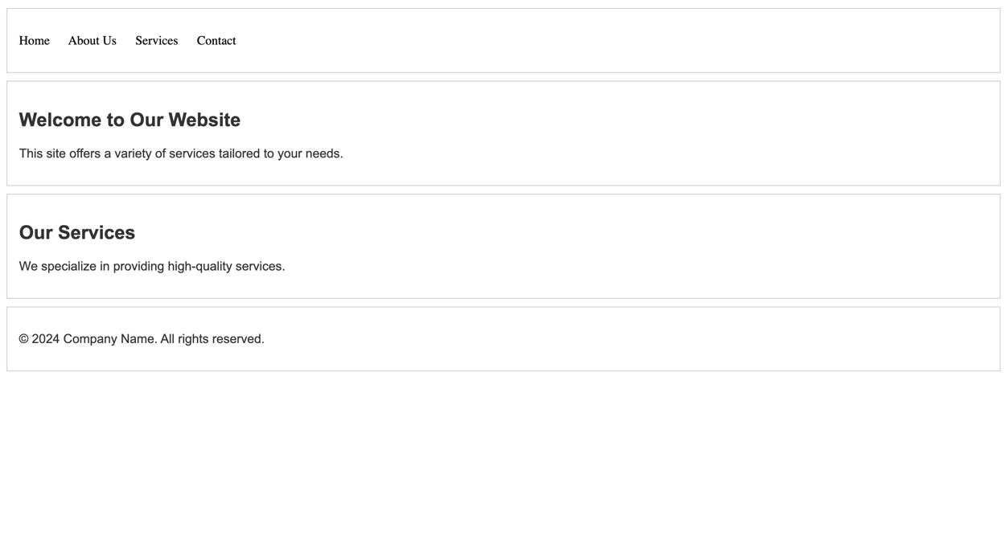

#### Requirements

Create an HTML document and apply CSS styling using selector lists to demonstrate your understanding of applying a single set of styles to various elements by grouping multiple selectors together.

* **HTML Document Setup**:
  + Create an HTML document named **selector-list.html**.
  + Include a variety of elements to allow for the application of selector lists, such as **<header>**, **<nav>**, **<section>**, **<footer>**, **<h1>**, **<h2>**, **<p>**, and **<a>** elements. Ensure these elements can logically share some styling to demonstrate the concept effectively.
* **CSS File Setup**:
  + Create a CSS file named **selector-list.css**.
  + Link the **selector-list.css** file to your **selector-list.html** document using the **<link>** tag in the **<head>** section.
* **Selector List for Text Styles**:
  + Create a selector list that targets **<h1>**, **<h2>**, and **<p>** elements to apply a unified font family and color.
* **Selector List for Layout Styles**:
  + Use a selector list to apply margin and padding styles to **<header>**, **<section>**, and **<footer>** elements to ensure consistent spacing throughout the document.
* **Selector List for Hover Effects**:
  + Implement a selector list that targets links (**<a>**) in various sections (**<nav>**, **<section>**, **<footer>**) to apply a hover effect, demonstrating the use of selector lists to handle interactive states.
* **Combining Different Types of Selectors**:
  + Demonstrate the use of selector lists that combine simple, compound, and complex selectors to apply styles to a group of elements that do not share the same parent or type.

#### Resources

* [https://developer.mozilla.org/en-US/docs/Web/CSS/CSS\_selectors/Selector\_structure#selector\_list](https://developer.mozilla.org/en-US/docs/Web/CSS/CSS_selectors/Selector_structure" \l "selector_list)